KCH3 -

Functionality
A
profit center group is a hierarchical structure of profit centers.
You can use profit center groups to group profit centers together according to company-specific criteria. Profit center groups are used for reporting, allocations or in various planning functions, where it does not make sense to enter or display data at the lowest level (with a high level of detail).

Scenario
This transaction is used to display a profit center group.

Requirements
Profit Center Group was already created.

Menu Path | SAP menu → Accounting → Controlling → Profit Center Accounting → Master Data → Profit Center Group → KCH3 - Display
Transaction Code | KCH3

1. Double Click on KCH3 – Display.

Display Profit center group: Initial Screen

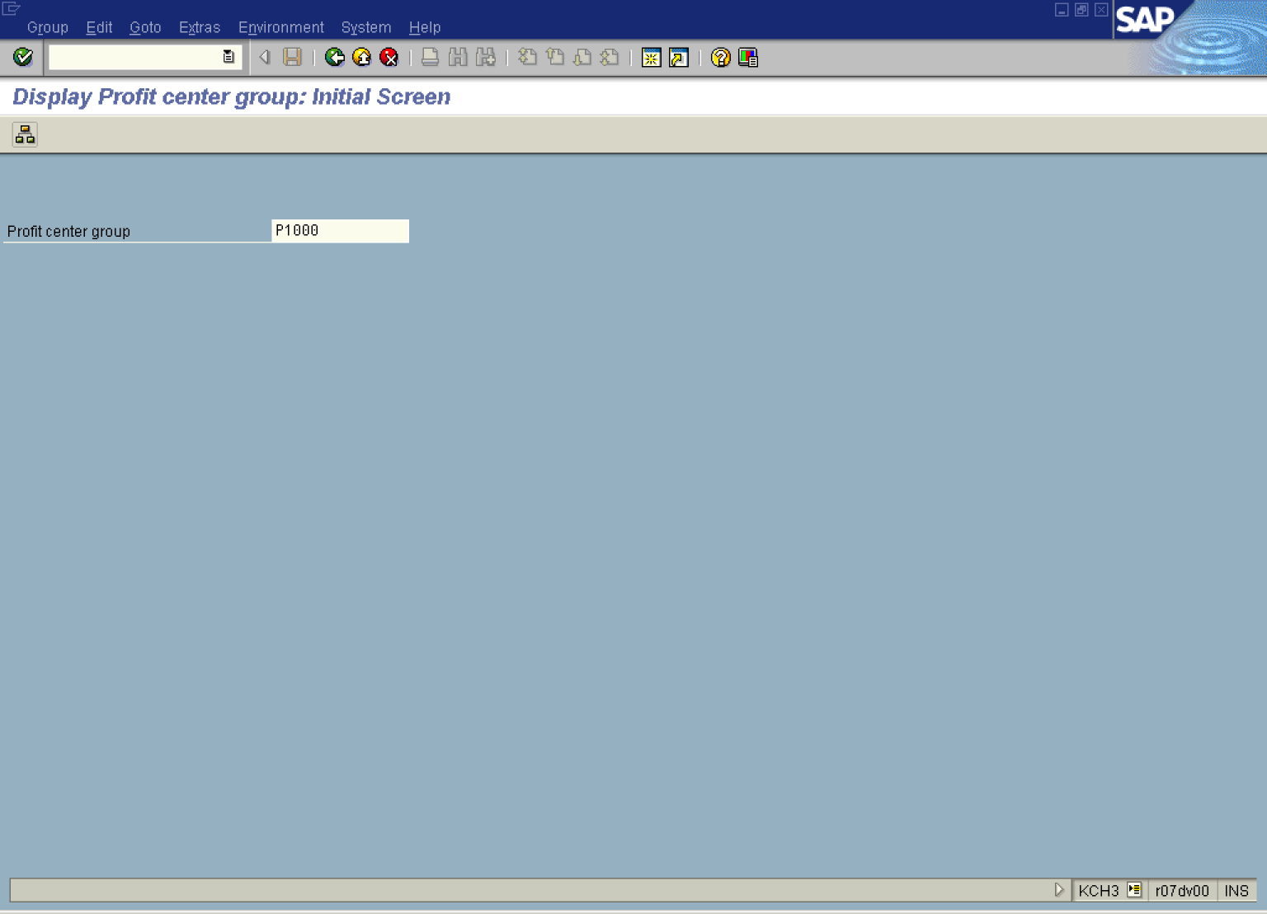

2. Update the following fields:

Field Name | Field Description | Values
Profit Center Group | Code identifying uniquely an Group of Profit Centers | Example: P1000

3. Click Button .

Display Standard hierarchy (Profit center group): Structure

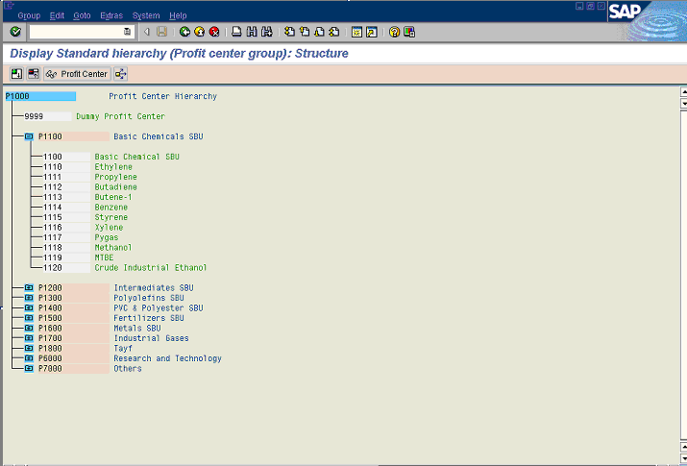

4. Click 1100 Basic Chemical SBU Button .

5. Click Profit Center Button .

Display Profit Center

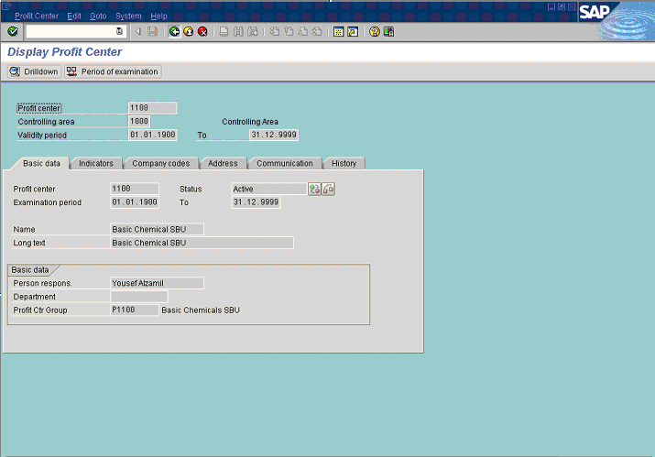

6. Click Back .

Display Standard hierarchy (Profit center group): Structure

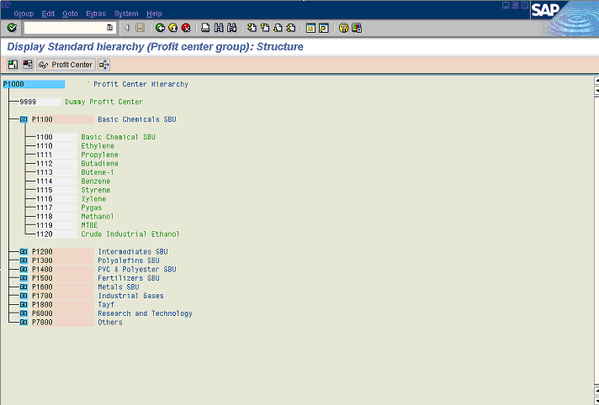

7. Click P1100 Basic Chemicals SBU .

8. Click Profit Center Button .

Use of Profit center group in ...

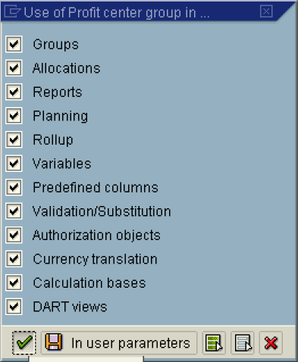

9. Click In user parameters Button .

10. Click Button .

Where-Used List

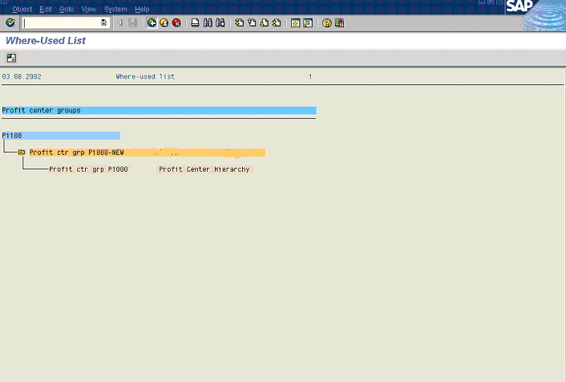

11. Click Back .

Display Standard hierarchy (Profit center group): Structure

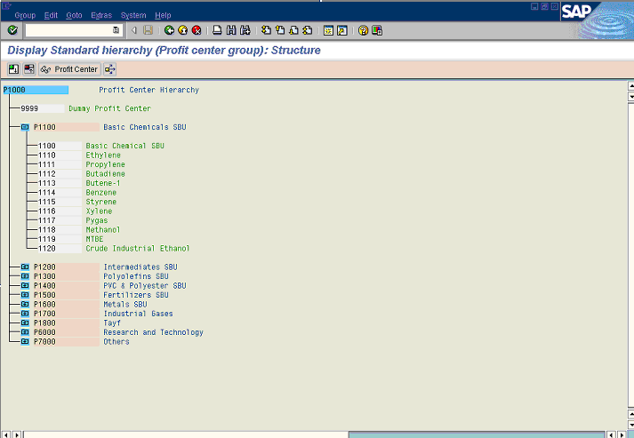

12. Click Back .

